**Project Report On**

**SMART HOME AUTOMATION**

***Submitted By***

#### HARSH CHAUHAN (180163107005)

**JAYDEEP VIRANI (170160107123)**

**PARTH UNJIYA (170160107118)**

**VAIDIK RADADIYA (170160107091)**

**Guided By:** Prof. V.R PATEL



OCTOBER -2020

#### Submitted To,

Department of Computer Engineering & Information Technology Government Engineering College, Modasa

i

**ACKNOWLEDGEMENT**

I am extremely fortunately and greatly honoured to work under the guidance of **Mr.V.R.Patel sir** for his valuable guidance during the Project work, without which it would have been very difficult task.

I have no words to express my sincere thanks for valuable guidance, assistance and cooperation extended by all the Staff Members of the Department.

I would like to heartily thank to our Department for guidance and support during my dissertation. The discussions with them and their constant feedback helped me immensely in completing this Project work satisfactorily.

I would like to thank all the teaching and non-teaching staff members of my Department and my colleagues those who helped me directly or indirectly for completing of this Project successfully.

My acknowledgment would not be complete without mentioning my parents & my family members. I am specially thanking them for continuous

encouragement for my work.

#### Date :16/10/2020 Harsh Chauhan

**ABSTRACT**

Smart Home System is an IOT based system. In this application Clint, user are allowed to Access digital devices. Client can see & control their Devices on or off. This application is secure. Smart home provides security to open specific chamber by remotely.

#### CONTENTS

##### Page No.

**CERTIFICATE (ii)**

**ACKNOWLEDGEMENT (vii)**

**ABSTRACT (viii)**

**CHAPTER 1: INTRODUCTION**

* 1. Characteristics of existing system 2
  2. Overview of proposed system 2
  3. Scope 3
  4. Process model 3

CHAPTER 2: SYSTEM ANALYSIS & SPECIFICATION

* 1. User characteristics 5
  2. Feasibility study 5

CHPATER 3: DESIGN AND MODELING

* 1. Activity diagram. 8
  2. Us case diagram. 9

CHAPTER 4: METHODOLOGY 11

CHAPTER 5: DESIGN AND DEVELOPMENT

* 1. Project description. 13
  2. Code templates. 23

CHAPTER 6: TESTING 26

CHAPTER 7: LIMITATIONS AND CONCLUSION

* 1. Advantages and Disadvantages of the system. 29
  2. Future Scope. 30
  3. References. 31

**List of Figures**

**Fig: 1.1 Overall processing model 3**

**Fig: 3.1 Activity Diagram 8**

**Fig: 3.2 Us case Diagram 9**

**Fig: 5.1 Schematic diagram of the system 13**

**Fig: 5.2 Pin diagram 14**

**Fig: 5.3 Dimensions 15**

**Fig: 5.4 8-channel 5VDC relay board 15**

**Fig: 5.5 Circuit diagram 16**

**Fig: 5.6 PCB layout 17**

**Fig: 5.7 Jumper cable set 19**

**Fig: 5.8 Arduino IDE 20**

**Fig: 5.9 First login activity 21**

**Fig: 5.10 IP Entered 21**

**Fig: 5.11 The switch panel 21**

**Fig: 5.12 The gesture mode 21**

**Fig: 5.14 Sketch structure 23**

**Fig: 5.15 Basic sketch using ESP8266Wifi library 23**

**Fig: 6.1 Testing two different versions of NodeMCU 25**

**Fig: 6.2 Uploading sketch using Arduino IDE 26**

**Fig: 6.3 Testing the relay board with NodeMCU 26**

ix

# CHAPTER 1

### INTRODUCTION

#### Characteristics of existing system

#### Overview of proposed system

#### Scope

#### Process model

**INTRODUCTION**

* The Smart Home Automation System is an IoT based electronic system, which is constructed using the basic switching system, connected to a Wi- Fi enabled microcontroller device (ESP Wi-Fi 8266-12E).
* The user just needs a local area connection, with the help of smartphone, the user can control the basic home appliances, i.e. fan, bulb/lamps, etc. from anywhere in network.
* However, this controlling isn’t limited up to virtual application interface but the home appliances are switched ON/OFF using unique gestures of the user.

#### Characteristics of existing system.

* + A switch in a switch-board is an electrical component that can make or break an electrical circuit, interrupting the current or diverting it from one conductor to another.
  + Either be manually operated or automatic (based on temperature or other conditions).
  + If a switch is malfunctioning then it can be easily replaced.
  + The installation of a switch-board system is easy, almost every electrician can install it.
  + A user may or may not need the deep knowledge of electrical appliances to use this system.

#### Overview of proposed system.

* + The overall model looks like client-server based system where client requests to the server and it sends the control command to microcontroller and the corresponding pin/switch gets digital signal , either to turn ON or OFF, here the NodeMCU ESP8266 works as an HTTP server. As the name of the project “ *Smart Home Automation System*” suggests that it is automatic in terms of recognizing and implementing the command given by the user using the android application.

#### Scope

The user just need a local area connection, with the help of smartphone, the user can control the basic home appliances, i.e. fan, bulb/lamps, etc. from anywhere in network. Here, a user use Smart application for operating the configured appliances. Particular user acts as a client to the NodeMCU server and get responses at particular pins acquired for the no. of appliances.

#### Process Model

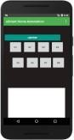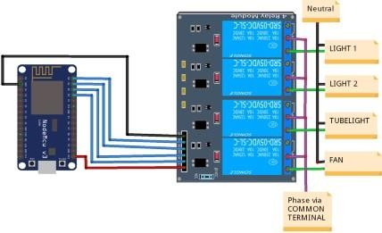

Smart Application

LAN

NodeMCU server

*Fig: 1.1 Overall processing model*

As shown in above figure, the user uses the Smart smartphone app and operates the appliances connected with *Smart Home Automation System.* NodeMCU server contains libraries for the digital signal generation and NodeMCU ESPWi-Fi firmware control.

Each Relay circuit’s trigger is connected to the digital pins of the NodeMCU circuit and phase lines of respected appliance is attached respectively to each relay module and other phase is given via COMMON TERMINAL.

# CHAPTER 2

### SYSTEM ANALYSIS & SPECIFICATION

#### User characteristics.

#### Feasibility study.

* 1. **User Characteristics**

The user/users of this system plays his/her role as a client and get the service of controlling home based electrical appliances locally in the LAN.

##### Client:

Here clients are the end users who use the application to operate their home appliances locally at their offices, homes, etc. Through the application client sends the HTTP GET requests to the NodeMCU server while connected to local network, the server replies back with the status of particular appliance whether it’s turned ON or OFF.

##### Server:

The NodeMCU is the local server which acts as an mDNS responder and shows feedback to client’s browser or the webview of the application. The user must know the local IP address of the server in terms to communicate with the server.

#### Feasibility study

Once scope has been identified, it is reasonable to ask whether we can build the system that meets this scope. Is this project feasible?

#### Technical feasibility

The user of this system shouldn’t require high technical skills to operate it, but yes he/she needs basic knowledge of the electronic component used. If the user has knowledge of online registration and login additional to the modules and the pins of the system he/she using, he/she can operate this system. So *Smart Home Automation System* is technically feasible.

#### Economic feasibility

Our project is cost effective as it consist no moving components or heavy load circuits to provide the user an accurate and effective service. We planned to make a cheaper and helpful system which falls under the budget of an average class client.

#### Behavioral feasibility

The *Smart Home Automation System* is functionally accurate and gives proper functionality which satisfies a user. It is accurate in terms of switching the particular appliance without any failure or misunderstandings and glitches.

# CHAPTER 3

## DESIGN AND MODELING

#### Activity diagram.

#### Usecase diagram.

* 1. **Activity diagram**

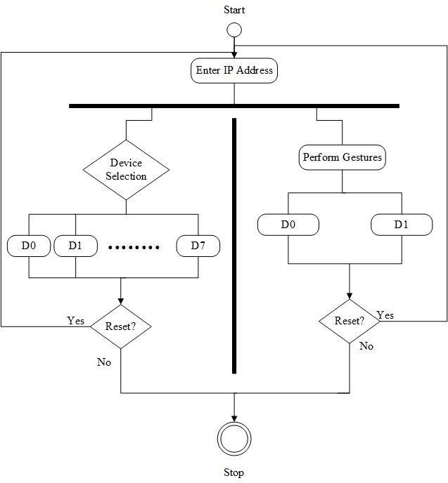

*Fig: 3.1 Activity Diagram*

* + The activity diagram represents the flow of activity in terms of behavior and designing an activity diagram helps the development team to recognize when the activity starts, which activity starts and when it gets terminated.

#### Us case diagram

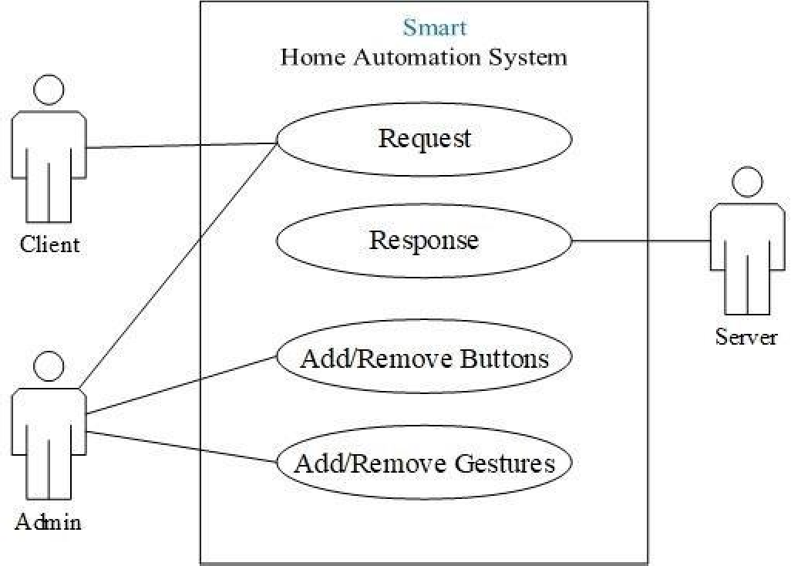

*Fig: 3.2 Us case Diagram*

* + The us case diagram is an UML diagram which represents the modules as actors of the system and their attachments which the use cases define in the system box. For our system there are currently 3 users:

##### Admin

The admin has the superior control over the system, he/she can test the system, Add functionalities like add/remove buttons, gestures and other functions.

##### Client

The client can request to the server for changing the status of appliances and observe the mode of pins on the browser or application.

##### Server

The server responses back to the user either the appliance is in turned ON mode or turned OFF mode via HTTP response on browser.

# CHAPTER 4

## METHODOLOGY

**METHODOLOGY**

* + We have used the latest NodeMCU ESPWifi8266 module which is an open source Iot platform and worldwide used for various purposes.
  + It has the central controller SOP (System on Chip) which can store programming code and control the devices connected to it.
  + This version of Wi-Fi module has a programmable controller along with Wi-Fi, so there is no need to attach it with other controller devices like Arduino/Raspberry Pi (for small scale projects).
  + The second circuit is the 8-channel Opto-coupler 5V relay module which performs the actual switching of the appliances connected to it.
  + Its pins are connected to the Wi-Fi module using Female to Female jumper cable.
  + Each relay circuit has voltage capacity up to 250VAC / 10A.
  + The controller is programmed with the basic HTTP web server code, the SSID and password of the source hotspot device.
  + After uploading the code the Web server (NodeMCU) gets a local IP, to which a user can send requests and get responses.

#### Components used:

* + - NodeMCU ESPWi-Fi 8266 – 12E
    - 8-channel Opto-coupler 5V relay board
    - Jumper cables
    - 5VDC Input source(we used 5VDC mobile charger)

#### Platforms:

* + - Arduino IDE
    - Android studio

# CHAPTER 5

## DESIGN AND DEVELOPMENT

#### Project description.

#### Code templates.

**DESIGN AND DEVELOPMENT**

This chapter contains the overall development and designing of our project and the requirements for better operability.

#### Project Description

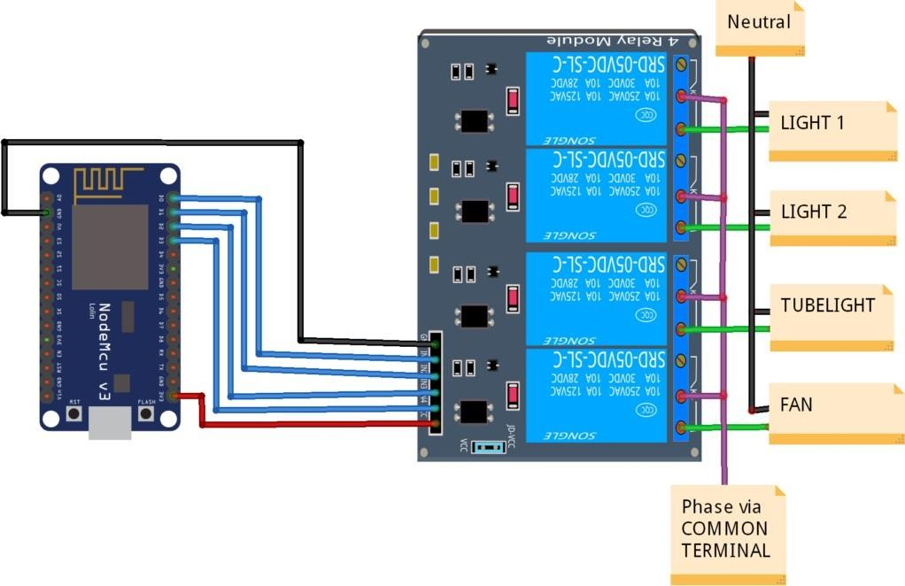

*Fig: 5.1 Schematic diagram of the system*

* + The above figure illustrates the implementation of the Automation System onto the home circuitry. One of the phase lines is attached respectively to each relay module and other phase is given via COMMON TERMINAL.
  + Each of the relay is operated at 5VDC and can handle up to 250VAC, the relay is triggered by the NodeMCU server.

#### Components used:

* + - 1. NodeMCU ESPWi-Fi 8266 – 12E
      2. 8-channel Opto-coupler 5V relay board
      3. Jumper cables
      4. 5VDC Input source(we used 5VDC mobile charger)

#### NodeMCU ESPWi-Fi 8266 – 12E

* + The NodeMCU is an open-source firmware and development kit that helps you to prototype your IOT product within a few Lua script lines.
  + The ESP-12E is one of the available modules containing an ESP8266 chip; it is becoming more and more popular because of its integrated Wi-Fi PCB antenna and shield.
    - Open-source
    - Interactive
    - Programmable
    - Low cost
    - Simple
    - Smart
    - WI-FI enabled

#### FEATURES:

The Development Kit based on ESP8266, integrates GPIO, PWM, IIC, 1- Wire and ADC all in one board. Power your development in the fastest way combination with NodeMCU Firmware.

* USB-TTL included, plug & play
* 10 GPIO, every GPIO can be PWM, I2C, 1-wire
* FCC CERTIFIED WI-FI module
* PCB antenna

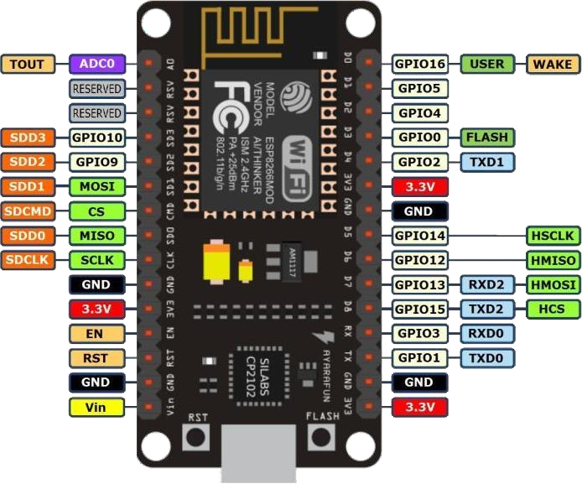

*Fig: 5.2 Pin diagram*

#### DIMENSIONS:

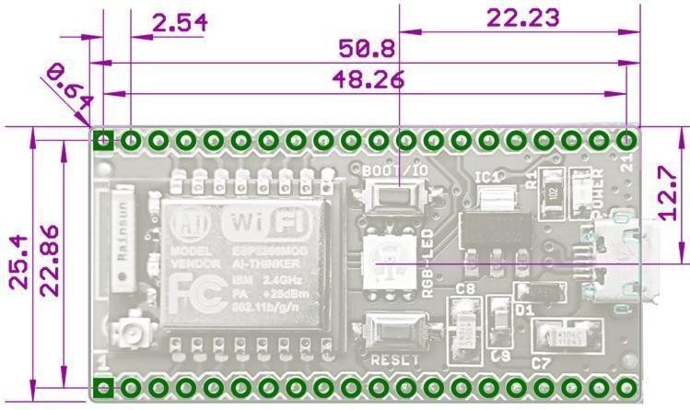

*Fig: 5.3 Dimensions*

#### 8-channel Opto-coupler 5V relay board

* + This is a LOW Level 5V 8-channel relay interface board, and each channel needs a 15- 20mA driver current. It can be used to control various appliances and equipment with large current. It is equipped with high- current relays that work under AC250V 10A or DC30V 10A.
  + It has a standard interface that can be controlled directly by microcontroller. This module is optically isolated from high voltage side for safety requirement and also prevent ground loop when interface to microcontroller.

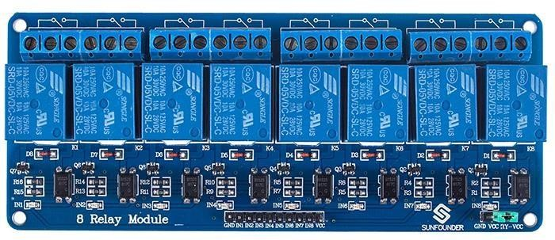

*Fig: 5.4 8-channel 5VDC relay board*

#### BRIEF DATA:

* + - Relay Maximum output: DC 30V/10A, AC 250V/10A.
    - 8 Channel Relay Module with Opto-coupler. LOW Level Trigger expansion board, which is compatible with Arduino control board.
    - Standard interface that can be controlled directly by microcontroller (8051, AVR,

*PIC, DSP, ARM, ARM, MSP430, TTL logic).

* + - Relay of high quality low noise relays SPDT. A common terminal, a normally open, one normally closed terminal.
    - Opto-Coupler isolation, for high voltage safety and prevent ground loop with microcontroller.
    - Module Board: 138 x 56 mm.

#### SCHEMATICS:

* + VCC and RY-VCC are also the power supply of the relay module. When you need to drive a large power load, you can take the jumper cap off and connect an extra power to RY-VCC to supply the relay; connect VCC to 5V of the MCU board to supply input signals.
  + If relay isolation is enough for your application, connect Arduino +5 and Gnd, and leave Vcc to JD-Vcc jumper in place.

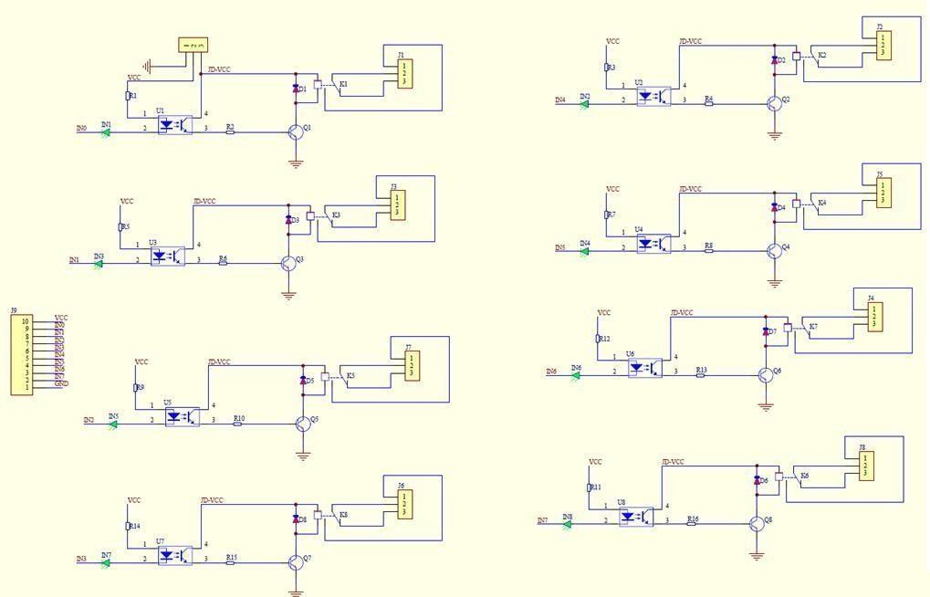

*Fig: 5.5 Circuit diagram*

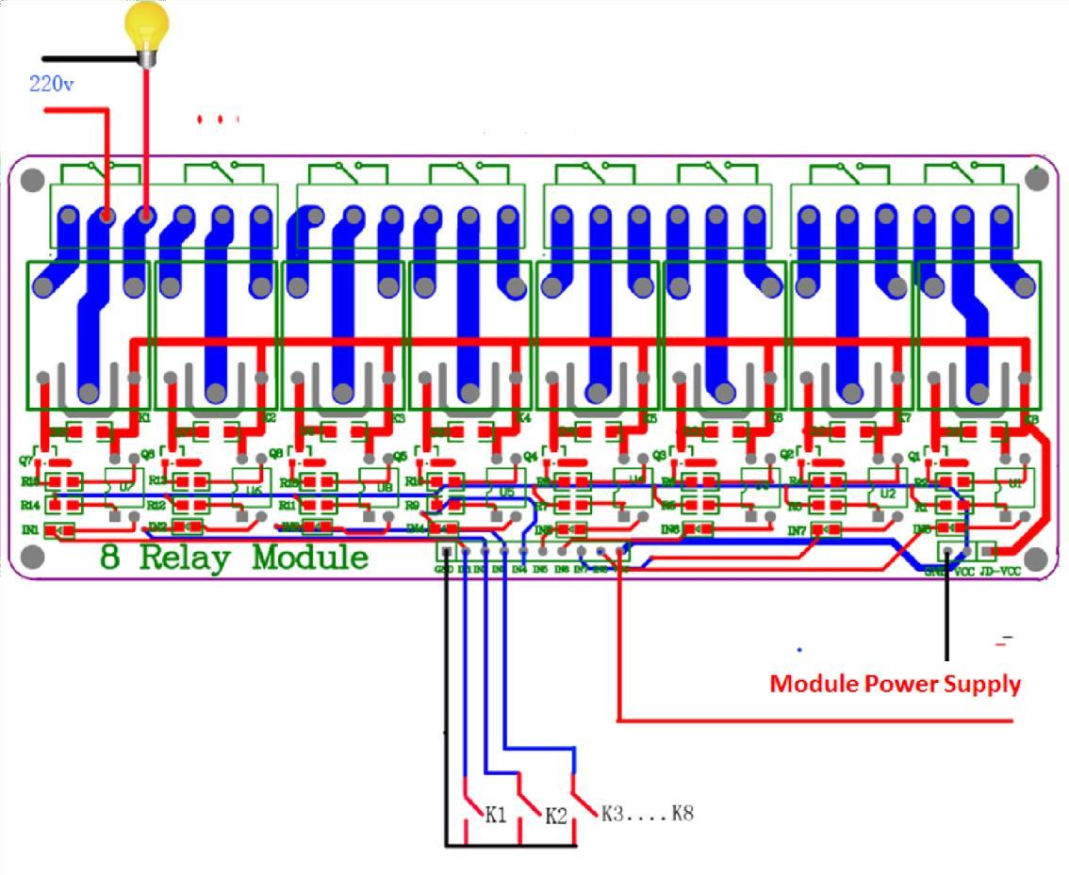

*Fig: 5.6 PCB layout*

* + It is sometimes possible to use this relay boards with 3.3V signals, if the JD-VCC (Relay Power) is provided from a +5V supply and the VCC to JD-VCC jumper is removed. That 5V relay supply could be totally isolated from the 3.3V device, or have a common ground if opto-isolation is not needed. If used with isolated 3.3V signals, VCC (To the input of the opto-isolator, next to the IN pins) should be connected to the 3.3V device's

+3.3V supply.

#### INPUT:

* + **VCC:** Connected to positive supply voltage.
  + **GND:** Connected to supply ground.
  + **IN1:** Signal triggering terminal 1 of relay module.
  + **IN2:** Signal triggering terminal 2 of relay module.
  + **IN3:** Signal triggering terminal 3 of relay module.
  + **IN4:** Signal triggering terminal 4 of relay module.
  + **IN5:** Signal triggering terminal 5 of relay module.
  + **IN6:** Signal triggering terminal 6 of relay module.
  + **IN7:** Signal triggering terminal 7 of relay module.
  + **IN8:** Signal triggering terminal 8 of relay module.

#### Jumper Cables

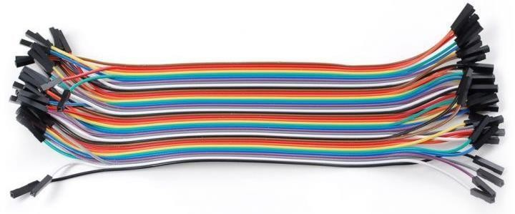

*Fig: 5.7 Jumper cable set*

* + These are most popular and flexible wiring cables while using Arduino or Raspberry Pi based projects.

##### Types of Cables:

* Male to Male
* Male to Female
* Female to Female

#### Platforms:

* + - 1. Arduino IDE

#### Arduino IDE

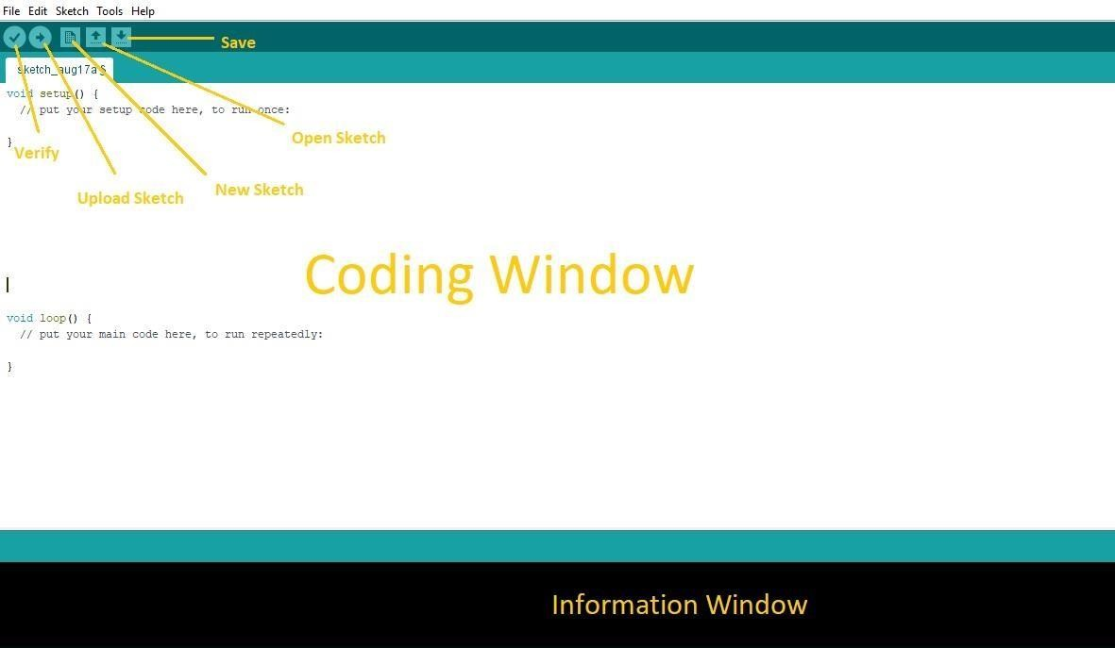

*Fig: 5.8 Arduino IDE*

* + The Arduino IDE is the tool, which we used to program the micro- controller of the NodeMCU ESPWi-fi8266 Module.
  + Arduino software is easy to use and free open source also available for all operating system like Windows, Linux, and Mac etc.
  + That software is based on C++ and we can easily write and verify, upload the program in Arduino board.

**Language:** Arduino(Consists: Java, Python, C++, C, etc.)

#### Code templates

* + Arduino has been used in thousands of different projects and applications. The Arduino software is easy-to-use for beginners, yet flexible enough for advanced users.
  + It runs on Mac, Windows, and Linux. Teachers and students use it to build low cost scientific instruments, to prove chemistry and physics principles, or to get started with programming and robotics.
  + The coding is based on C++ and many other different languages like python, java, etc.
  + In Arduino, every program has at least two methods:

1. **void setup()**
2. **void loop()**
   * Arduino platform is open-source and easy to use, it has user-friendly environment and has components like sketch editor, debug console, toolbar,etc.
     1. **Coding in Arduino IDE**

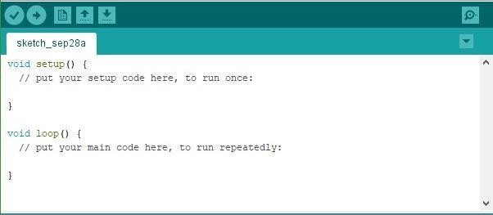

*Fig: 5.14 Sketch structure*

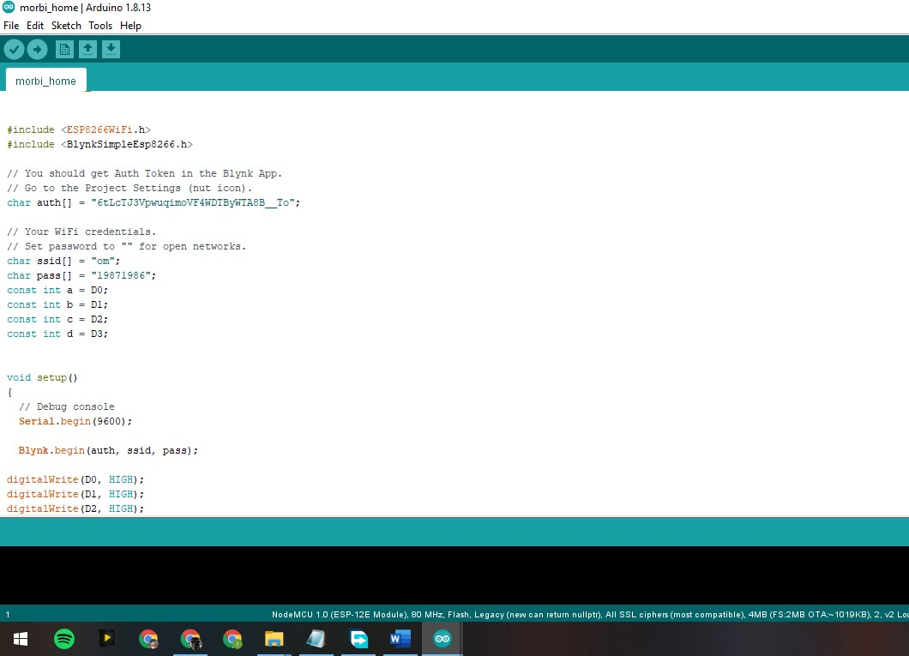

*Fig: 5.15 Basic sketch using ESP8266Wifi library*

# CHAPTER

## TESTING

#### TESTING

Testing is an essential part of any hardware based project with the aim of developing a trustworthy and interactive project model.

**6.1 Testing of hardware components**

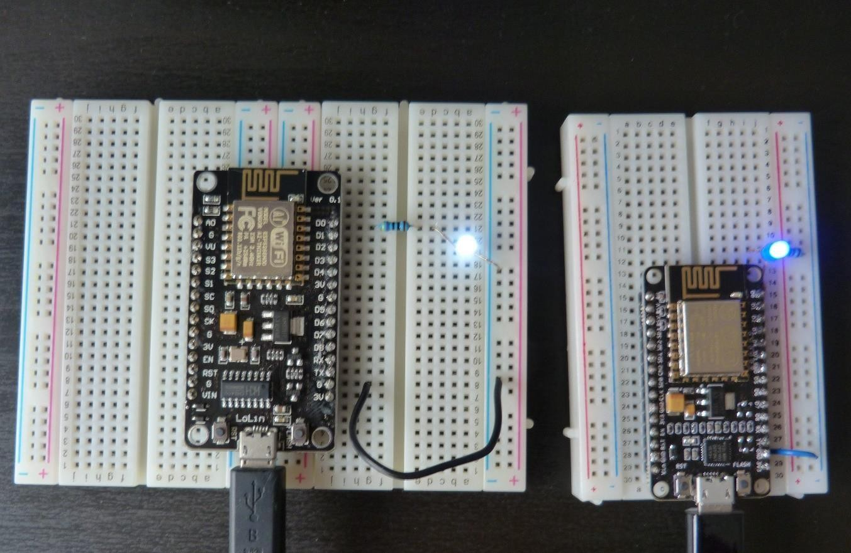

*Fig: 6.1 Testing two different versions of NodeMCU*

* + We first tested the two different versions NodeMCU circuit and checked its working on LEDs.
  + The LED logic HIGH represents that the pin is enabled and LED logic LOW represents that pin is disabled.

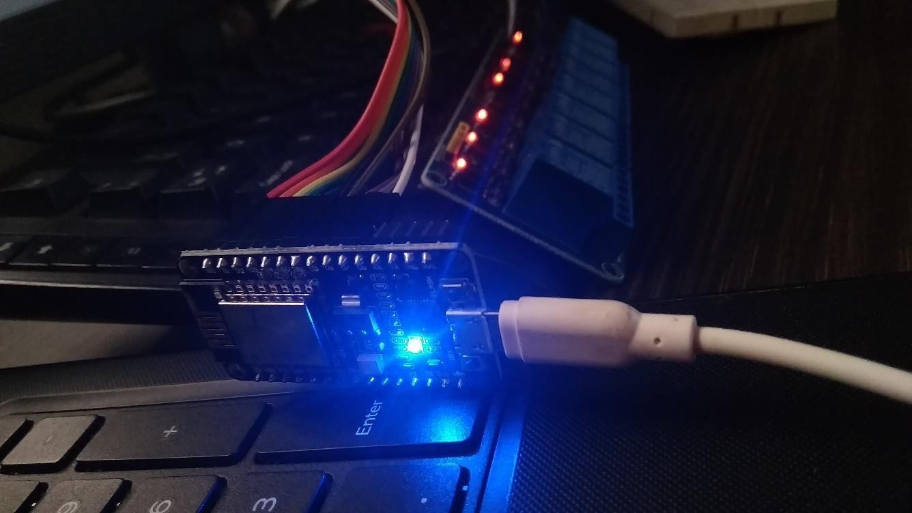

*Fig: 6.2 Uploading sketch using Arduino IDE*

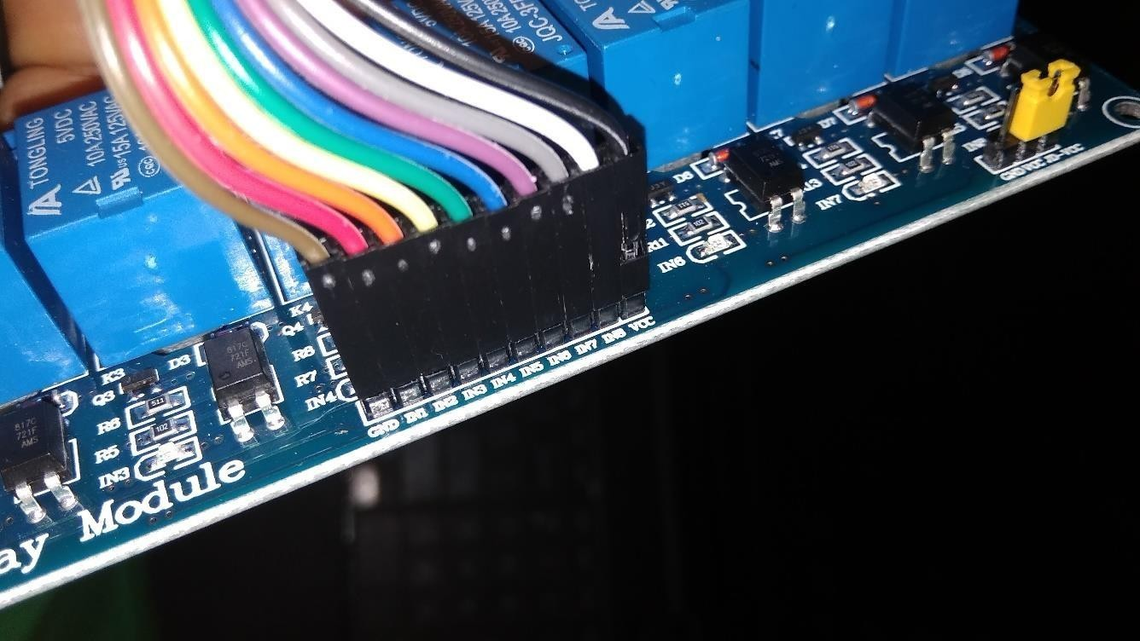

*Fig: 6.3 Testing the relay board with NodeMCU*

# CHAPTER 7

## LIMITATIONS AND CONCLUSION

#### Advantages and Disadvantages of the system.

#### Future Scope.

#### References.

* 1. **Advantages and disadvantages of the system**

As every existing system has some advantages and limitations, the proposed system has following advantages and disadvantages.

#### Advantages

##### Reliable

The proposed system is reliable and trustworthy as until any electricity overload, it serves a user the best functionality.

##### Portable

It is highly portable as it is lighter in weight and easy to be installed as many location as the user wanted to.

##### Accurate

It is accurate in terms of operations and actions are performed.

##### Simple

The platforms used for configuring it, has a user-friendly environment and easily understood by everyone.

##### User-defined

The user can define his/her own triggers and actions as well as the web request methods for the NodeMCU pins and configuring it.

##### Secure service

The proposed system consists Encryption enabled Wi-Fi and various encryption methods for securing the access control of the system.

##### Local access

The user can access the system locally while connected in local network.

#### Disadvantages

##### Needs maintenance

As the proposed system is based on hardware equipment, each and every module has a risk of get damaged by time so proper maintenance is needed.

##### Needs more circuits for overall buildings

One NodeMCU is efficient for single room, for expansion of this system we need more no. of NodeMCU circuits.

##### Complex wiring

The pin no. and the appliances has possibilities of mismatching and thus the proper table must be maintained, otherwise it will no more an accurate service.

##### No global scope

The current system is not capable to be accessed over remote connections or internet.

#### Future scope

* + We decided to learn more about the parts as well as pins of the components used, so we can add extra functionalities to our project.
  + We worked on the GPIO pins and further we’ll test it with other sensors as the ESPWifi is capable to connect 2-3 other devices like gas sensor and temperature sensor, etc.
  + We’ll find the ways to implement the system using fewer circuits.
  + Extending the project towards machine learning using python and lisp.
  + We are currently working on the remote access of the NodeMCU server over the internet.

#### References

##### Iotbytes

<https://iotbytes.wordpress.com/esp8266/>

##### Arduino

[https://www.arduino.cc](https://www.arduino.cc/)

##### Github

<https://github.com/arduino/Arduino>

##### GeeksforGeeks

[https://www.geeksforgeeks.org/robotic-process-automationrpa-google-form-](https://www.geeksforgeeks.org/robotic-process-automationrpa-google-form-automation-using-uipath/?ref=rp) [automation-using-uipath/?ref=rp](https://www.geeksforgeeks.org/robotic-process-automationrpa-google-form-automation-using-uipath/?ref=rp)

##### Android

<https://developer.android.com/studio>